***PAAREES PERFUMES***

***VERSACE***

***FOR WOMEN***

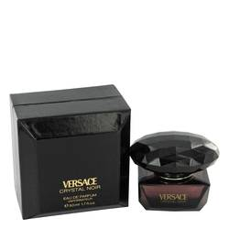

# 

# *Crystal Noir*

## *Description:*

Crystal Noir by Versace Perfume. Released in 2004, Crystal Noir by Donatella Versace is a long-lasting women's fragrance with a sensual and delicate aroma that resonates long after application. Notes of ginger, cardamon, peony, pepper and gardenia mix for a feminine white floral, spicy and coconut accord. Crystal Noir is perfect for the working woman seeking a scent that holds firm without standing out. Spray it on in the morning to increase your confidence as it takes you from the office to wherever your evening leads and beyond.